**TABLE OF CONTENTS**

Page

Chapter 1. What is NMI .........................................

Chapter 2. Top 6 Areas of Impact of NMI ..............

Chapter 3. Strategies of NMI, monthly emphasis..

Chapter 4. Responsibility of NMI in the new

Missions strategy ………………………………

Chapter 5. What is WEF? .…………………………………..

Chapter 6. Ideas to carry out the work of NMI …..

Chapter 7. Links to download resources …….……….

**INTRODUCTION**

This handbook is a compilation of the resources of Nazarene Missions International (NMI) that will serve to train the local churches by providing all the information about missions, the six areas of impact, including the purpose and use of WEF and the monthly emphases.

It is my desire that churches continue to work in the ministry even in times that we cannot meet physically but we can communicate through other means given that missions continue regardless of the circumstances.

God bless you!

***Ana María Crocker de Díaz***

***Regional NMI Coordinator***

***August 2020***



CHAPTER 1

**WHAT IS NMI?**

**HISTORY OF NAZARENE MISSIONS INTERNATIONAL**

In response to the Great Commission of Christ, various groups and denominations established missionary organizations. Nazarene Missions International (NMI) had its origin in the Association of Pentecostal Churches of America (APCA), when in April of 1899 the Women’s Missionary Society (WMS) was founded.

The WMS was officially recognized as an auxiliary organization of the Church of the Nazarene in 1915 at the fourth General Assembly. It was recommended that there be an organization in each local church to increase knowledge and interest in missions through prayer, by obtaining special speakers, by keeping in touch with the missionaries; and to cooperate with the local Church Board to increase their contributions for missions.

The first General WMS Convention was held in June 1928; and it was at that Convention the members of the General Council were elected by the Convention (before that, the Council was elected by the members of the General Assembly).

The name of the ministry has changed over the course of its history: 1928 – Women’s Foreign Missionary Society (WFMS), 1952 - Nazarene Foreign Missionary Society (reflecting the introduction of men, youth and children in the organization), 1964-Nazarene World Missionary Society, 1980: Nazarene World Mission Society (reflecting the international aspect of the organization), and in 2001 Nazarene Missions International (NMI)

The purpose of NMI is to mobilize the Church of the Nazarene in missions through 1) Praying, 2) Giving, 3) Educating and 4) engaging children and youth.

NMI is the direct line for missions in the local church and is often described as "the face of mission in the local church." In every sense of the word, NMI is the denomination’s organizational representative, dedicated to the cause of world evangelization. While other departments also support missions, the distinctive task of NMI is to bring each mission area to the local church in such a vital way that every Nazarene will be happy to be part of global outreach, spreading the good news of full salvation (holiness) to the ends of the earth. NMI provides the infrastructure, the spiritual dynamic vehicle, through which the local church is mobilized in mission.

What is the role of the local NMI president?

The role of the local NMI president is to promote this ministry in the local church in cooperation with the pastor and the church board and to direct the local NMI council.

How should I lead our local NMI Council?

Consult the Constitution of NMI in the Church of the Nazarene Manual, Article V, Section 1.

How do I organize an NMI Council in a small church or in a large church?

Talk to your district president about how to proceed in your specific situation. He/she will guide you to do so in the most effective way that will involve the entire congregation.

Is the local NMI president a voting member of the church board?

Yes, they are voting members of the church board. Please see I. Local Government, K. The local Church Board in the Manual.

What should I focus on in my local church?

We believe that there are six key Impact areas in which all churches could participate, regardless of their size, location or language.

These are the NMI six main areas of impact: Prayer, World Evangelism Fund, Alabaster Offering, Engaging of children and youth, Links and Genesis Initiative – the latter only in the Mesoamerica Region.

Focusing on these six areas of impact does not diminish other areas of NMI influence. These articles are steps for a deeper participation in the support of missions through the Church of the Nazarene. They are ways to start getting involved, they are easy to understand and we strive to be adaptable in each culture. Our goal is for each church to participate in these five areas, and then add additional areas of connection (monthly emphases) to match the interests and needs of each local congregation or district.

Nazarene Missions International is the heart of the relationship between Global Missions and each local Church around the world.

**NMI** exists at a general, district and local level to serve as support for the missions of the Nazarene Church around the world.

**NMI** exists because it is the direct line for missions in the local church.

**PURPOSE OF NMI.**

Mobilize the Church of the Nazarene in its mission: Make Christlike Disciples in the Nations.

**OBJECTIVES OF NMI:**

It is to Unite in the Vision and to move forward in Action with the purpose of making an IMPACT for Jesus in the world and in all cultures through PRAYER, OFFERINGS, EDUCATION and the involvement of CHILDREN and YOUTH in missions.

The entire church can participate in all aspects of NMI regardless of its size or location:

* To encourage people to pray for all efforts of world evangelization.
* To inform people of the world’s needs and what the church is doing to meet those needs.
* To challenge children and youth to learn about and participate in the mission of the church
* To raise funds for missions outreach.

**NMI** helps produce missionaries.

**NMI** assists in sending missionaries to the field.

**NMI** supports missionaries in the field.

**NMI** educates individuals and congregations about the missionaries’ work on the field.

**NMI** welcomes missionaries when they return for home assignment.

**NMI** helps equip missionaries to return to the field.

**Notes**: ___________________________________

_________________________________________

_________________________________________

_________________________________________

_________________________________________

_________________________________________

_________________________________________

_________________________________________

_________________________________________

_________________________________________

_________________________________________

_________________________________________

_________________________________________

_________________________________________

Chapter 2

**TOP 6 AREAS OF IMPACT**

**NMI** focuses on Top 6 Areas of Impact for the development of the ministry mentioned earlier and that will be detailed below.

**PRAYER**

To make "Christlike Disciples in the Nations" PRAYER is the main step.

**NMI** holds the region together during the year through times of prayer:

* **Every first Sunday of the month:** PRAYING AND FASTING for different needs, but also that we can meet the goal of becoming 1 million members by 2030 in the Mesoamerica Region. Each area has set its goal and we pray that as we unite together in prayer, we will achieve it.

**The Nazarene World Week of Prayer:** This takes place every year in the first week of the month of March, and during this time, we intercede for the different requests that each region of the Church of the Nazarene sends, praying daily for each and the seventh day, interceding for those cities and countries where the church is not yet present. It will begin on February 24 and end on March 2.

**40 Days Praying for the City:** During this time, we intercede for our cities and Global Mission and Genesis Initiative provides the daily requests that begin on January 1st of each year.

**40 Days of Prayer prior to Pentecost:** This period varies each year, for 2020, it will begin on April 22 and end with the Global Day of Prayer, on May 31. We encourage all congregations to come together at this time to build lives in prayer. NMI provides a Daily Prayer Guide that is sent to each district.

**Freedom Sunday:** It is usually the third Sunday of September. This year 2020, it is the 20th.Thousands of churches from all over the world unite in observing Freedom Sunday. This special day has been set apart so that congregations PRAY, learn and support the efforts directed by the churches against human trafficking. The churches will plan the Freedom Sunday service to inform and unite the congregations in prayer. Congregations are also encouraged to discuss action that can be taken, both globally and locally.

**International Day of Prayer for the Persecuted Church: "**Please pray for us ..." is the cry of persecuted Christians throughout the world. Today, millions of them are suffering for their faith in Jesus Christ. Each year, Christians in more than 130 countries pray for our persecuted brothers on the International Day of Prayer for the Persecuted Church (IDOP). Please, let us unite in prayer for our brothers who suffer because they declare their faith in Christ. This year 2019, we will join in prayer for them on November 3 and the petitions will be sent to the leaders of the districts and in due course, the date for 2020 will be revealed.

**Prayer Line of the Mesoamerica Region:** This is sent electronically to the leaders of the region each week -prayer requests for our leaders, missionaries and requests that arrive from the different districts. Those who have email can subscribe to:

[adiaz@mesoamericaregion.org](mailto:adiaz@mesoamericaregion.org)

**Prayer Mobilization Line:** The Prayer Mobilization Line (PML) is a weekly publication that focuses on prayer needs and praise reports by the global ministries of the Church of the Nazarene about the work of our missionaries. It is available in Spanish and English. Everyone can subscribe to receive the PML, free of charge, by email at this link:

<https://us16.campaign-archive.com/home/?u=304f5aa03caa8a6cf9a099547&id=5d51637314>

**WEF**

**World Evangelism Fund**

In our new plan for Funding the Mission, the World Evangelization Fund is the vehicle by which we send the message of hope-and the church drives our mission today more than ever.

The Church of the Nazarene has always been very involved in missions. The church is currently reaching the entire world in more than 162 areas. Whether it is evangelism at home or abroad, it is essential that we strive to spread the gospel in everything we do. To achieve this, our churches around the world come together voluntarily giving their time, prayer and financial donations. Throughout the world, Nazarenes are thrilled to give for the good of others.

The cost of missions in the Church of the Nazarene totaled more than $ 1 billion (USD) at the end of its first 100 years. The money raised for the specific needs of missions includes another 500 million. This legacy of generosity continues to inspire us as we work to fund the mission of the church to "Make disciples like Christ in the nations."

The Church of the Nazarene strives to use money wisely to create the greatest possible impact. While the Mission Funding formula allocates about 25% less to the structure of the church and its organizational support from the ministries than the previous formula, the global mission is becoming more effective. The Church of the Nazarene continues to prosper, as it has done historically, due to the generosity of its members

Each Church of the Nazarene is part of the financing, contributing at least 5.5% of its income from TITHES and REGULAR OFFERINGS.

Each church gives 5.5% of the funds received from these two sources and sends the amount monthly where appropriate.

Another way to raise it is through the Easter, Thanksgiving, Prayer and Fasting and Faith Promise offerings.

By 2030, the Mesoamerica Region proposes to reach 1.5 million dollars for this fund as part of the regional Faith Goals and each year the corresponding goal will be published.

The goal for the year 2020 - 2021 is $ 660,950.05.

The annual statistical period of the offerings begins on October 1st of each year and ends on September 30th of the following. So it is required that each district take into account the following dates so that they reach the respective area offices on time: 15th of January, May 15th and September 15th or the date that each of them chooses, especially the month of September.

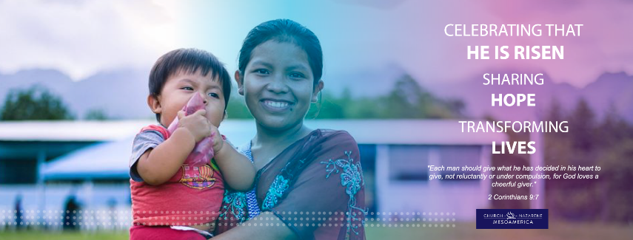

**Notes:** ___________________________________

_________________________________________

_________________________________________

_________________________________________

_________________________________________

_________________________________________

**ALABASTER OFFERING**

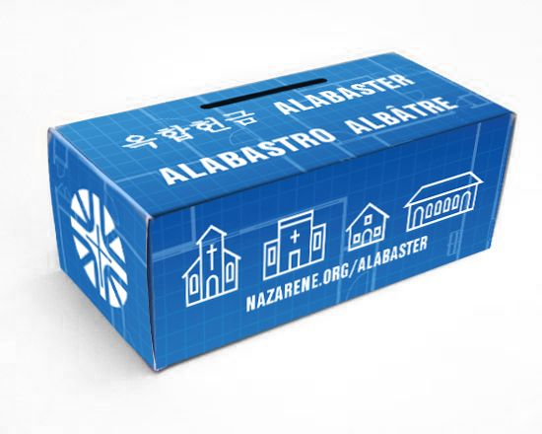

The Alabaster Offering provides funds for property and buildings around the world. While we understand that the church consists of the people of God and not a building, the buildings improve ministerial efforts and convey the attitude that the Church of the Nazarene intends to "put down roots."

Alabaster funds help provide land for many Work and Witness projects and the entire Alabaster Offering goes toward the purchase of land and construction of churches, schools, medical facilities and homes for missionaries and national workers.

Adopted in 1949, the Alabaster Fund continues strong, having provided funds for more than 9,000 projects since its inception. Faithful Nazarenes around the world have given close to $ 115 million dollars (USD) for this much-needed ministry.

The Alabaster Offering reaches the mission field in various ways. The most used is the Alabaster Box. Individuals have the challenge of contributing regularly to the cost of the items they want but do not need. The boxes also serve as reminders to pray for those people who will benefit from the Alabaster buildings.

The money is collected in September and February. Many churches receive regular offerings throughout the year that are designated as Alabaster Funds. (This is usually part of the faith promise plan for missions). However, semiannual offerings in September and February are traditional in the Church of the Nazarene.



An Offering of Love with Fragrant Odor!!

**ENGAGING CHILDREN AND YOUTH**

NMI recognizes that the vision of the world and the interests of a person are configured and developed in the early years. Therefore, NMI emphasizes the importance of involving children and young people today and as we look to the future.

NMI challenges children and young people to:

* Commit to God: to know him through the person of Jesus Christ.
* Commit to God's mission: to learn about global missions and the people who carry out that mission.

Statistics indicate that 50 percent of the world's population is under 24 years old, and 30 percent is under 15 years old. Therefore, the next generation include children, adolescents and young adults under 24 years of age. NMI involves this age group with a passion to fulfill what Christ ordained in the Great Commission.

The next generation can identify with the word "passion". Even with the many problems they have in their own cultures, they tend to be totally committed to everything they do. Therefore, the church and NMI must help the next generation to be passionate about God and his mission.

Consider these important steps to create passion in the next generation:

* **Be there.** They need people they can count on, and who show interest in them.
* **Be passionate.** They want people to be authentic and real. Mission leaders must be passionate to help others develop a passion for missions.
* **Be a community.** They want to belong to the community that form NMI and the church and feel that they are important in God's mission. Being with other Christians helps develop a sense of belonging.

**¿** **How can we mentor our youth and children to make them part of God's mission?**

Most missionaries state that they first felt God's call for a global service as a child or young person. Therefore, the church should help each child and young person to discover God's call to be encouraged and mentored. Here are some ways you can do it:

* Help them develop a relationship with God through personal Bible study, prayer and worship.
* Help them get involved in the life of the church.
* Help them learn about the needs of the church and the global mission.
* Help them develop their gifts and abilities given by God.

NMI recommends that local churches select a person to guide children and youth in their missionary call. This person will be the Local Missionary Call Coordinator.

NMI needs leaders in each generation to equip, discipline and guide future generations. Therefore, NMI leaders in each church and district must develop a plan to achieve this goal.

Consider these ideas:

* Identify people of all ages who indicate an interest in global missions.
* Select leaders of all age groups to be part of the NMI council.
* Encourage and involve new people in missionary strategies and events.
* Include children and young people in all missionary activities.

**MISSIONS FOR YOUTH**

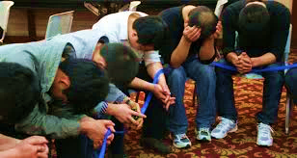

**Fulfilling the Task**

If we want the younger generation to participate in the life of the church, our minds, hearts and actions must adapt to minister to the young within the reality in which they live.

**Reporting**

One of the principles of education is to transmit information from one person to another.

**Participating**

There is no better way for young people to learn about missions than to get involved. We must help our congregations get involved in the lives of those in need, and help meet their needs. The Church of the Nazarene provides us with many opportunities for participation. Not everyone can go, but everyone can give, pray, and support missions.

In the Mesoamerica Region, there are many opportunities where young people can get involved such as Youth in Mission, Project Paul, Maximum Mission, 4 x 4 Project, Genesis Initiative, Work and Witness, among many others, but ...

How can we intentionally add children to our missions’ ministries and programs?

**MISSIONS FOR CHILDREN**



Nazarene Missions International is committed to involving children in the mission of the church.

Children between the ages of 5 and 13 have a 32% chance of accepting Jesus Christ as their Savior. In contrast, adolescents between the ages of 14 and 18 years is 4%.

Children are more likely to hear God's call to full-time Christian ministry (missionaries, ministers, etc.) between the ages of 4-14.

Here are 5 reasons to invest in children:

5 years: The best time of learning

* 6 years: Moral values are established for life
* 9 years: The worldview is formed for life
* 12 years: The entrance to maturity is celebrated
* 13 years: Religion is decided for life.

Why involve children in missions?

* Children are sensitive to God.
* They can begin to learn about God's heart for missions at an early age.
* Children easily understand the concept of compassion.

We must sow the seeds of missionary interest at an early age if we hope to gain missionary recruits and strong missionary supporters in the years to come.

To involve children in missions in the local church, the International Mission Education Guide contains a series of 12 lessons for children that can be used both in the Children's Church and in a Vacation Bible School with an emphasis on missions. (Although they do not provide it now, I am working on authorizing us to translate those produced in other languages).

**MISSIONARY CARE**

Missionary Care is an important strategy of Nazarene Missions International (NMI) to help provide for the personal needs of missionaries. These expressions of attention to our missionaries include:

**LINKS**

In **NMI** we connect with the missionaries through **LINKS**.

**LINKS**, strategically connects Nazarene missionaries with the Churches of the Nazarene through prayer, communication and generous offerings.

The participating missionaries are assigned to the districts and then, from the district level, they are connected to the local churches.

This gives each church the opportunity to personally become acquainted with a family of missionaries and their area of service.

The LINKS relationship fosters a sense of participation in the global enterprise of the missions of the church through correspondence with the missionaries, updates of their service area, and even through deputation services or missionary tours, while the missionaries are in assignment in its place of origin.

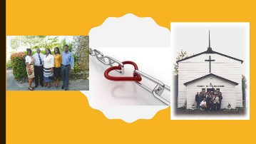Missionaries and churches experience close relationships built over time that are a result of a common bond.

Other expressions that are part of Missionary Care are

**The Missionary Christmas Fund:** offers a monetary Christmas gift for the missionaries, as well as subscriptions to Reflecting God and Holiness Today.

**How will our church make a LINKS connection?**

Contact your district NMI President for details regarding the family of missionaries linked to your church.

**THEN…**

* Make personal contact with the missionary.
* Agree on the best way to communicate.
* Introduce the missionary to the church.
* Learn as much as possible about the missionary and his field of service.
* Share as much as possible about your church with the missionary.
* Pray for each other regularly.
* If possible, schedule a time to meet in person.

**How can we foster missionary bonds?**

Consider your LINKS missionaries as part of the family of your church.

* Share experiences with each other.
* Pray for each other.
* Communicate often.
* Meet in person or connect through a video call
* Give generously to them.
* If possible, schedule a visit from your missionaries to visit your church.

**How can your church send gifts to its LINKS missionaries?**

Generosity is one of the greatest expressions of love. If an individual, church or district would like to show love to a missionary assigned to assigned LINKS, please follow these guidelines:

* Please contact the district NMI president, coordinator or secretary of the district's LINKS, or the missionary.
* Make sure of the address so that the packages arrive at their destination.
* Before sending packages or gift cards, contact the missionary about their wishes / needs, and for specific shipping instructions.
* To ensure the best results, send articles directly to the missionary following the instructions given.
* Include your e-mail address with the items sent so that a thank you can be returned.

For sending monetary donations note that NMI encourages congregations to give, but does not set amounts. Please, give as the Holy Spirit guides you.

For most districts in the Region, send the money through your Field Office so that upon arrival at the Regional Office, the funds will be remitted to the Global Treasury at the Global Ministry Center.

When sending the funds, clearly include "the name of your LINKS missionary" with the remittance.

**Missionary Health Care**: the money collected is used to subsidize the health costs of the missionaries. The money that is collected comes from:

* The Memorial Roll: a way to honor deceased friends and loved ones. A certificate is issued in the name of the deceased person and is often presented to a member of the family or the church represented.
* Distinguished Service Award: is a certificate presented to an individual to recognize his outstanding service to God and the church. The presenter (usually a church or district) contributes $ 15 or its equivalent to Missionary Health Care.
* 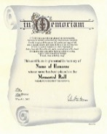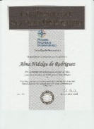Gifts from the Heart: they are donations of any amount given in honor and / or to remember friends and loved ones; the money is designated for medical missionary care.

**GENESIS INITIATIVE**



Involves the starting of ministries and churches in 28 areas of the Mesoamerica Region. Twenty- four of these areas already have a Nazarene church, however more work is needed as these are urban areas and the church does not have a strong enough presence.

**General Objective**

Starting new churches that are alive, united, holy, believers and as a result new ministries during the next few years.

**Specific objectives**

* Improve the work of existing churches so that they can become mother churches.
* Strengthen the missionary call in the church members.
* Mobilize the church in the whole region so that it can be a missionary church.
* Organize the Church of the Nazarene in countries that do not have them.
* Unite the vision of the Church of the Nazarene of the Region through teamwork in church members and leaders.
* Genesis aims to unite the work ministry through the known objective. However, all the ministries of the church are involved as well as other roles and responsibilities.

**The role of NMI in the Genesis Initiative**

* Assist in the promotion of the project so that it can reach each local church.
* Promote the project in the area where the work will start.
* Involve the missionary that arrives or that each district sends.
* Promote and direct the collection of offerings in the local churches where the voluntary missionaries are sent.
* Promote the special offering for Genesis during the month of February. The goal is to raise one dollar per member of a local church. These funds are for the training and other resources needed for the missionaries.
* Take care of the missionaries during their time of service be it those sent or those received.
* In collaboration with the local coordinator find a family willing to house one, two or four volunteers during their time of field work. This is not a requirement but it is one way to reduce costs and accelerate the culturalization, as well as identification with the community and care of the missionary.

**Notes: ­­**___________________________

___________________________________

___________________________________

___________________________________

___________________________________

___________________________________

___________________________________

___________________________________

___________________________________

___________________________________

___________________________________

Chapter 3

**THE STRATEGIES OF NMI**

**THE MONTHLY EMPHASIS AS OF 2018**

Why the monthly emphasis?

* So that it can be easier to fulfill the purpose of NMI.
* To be active each month and year in the plans of NMI.
* It serves to require us to establish our plan each year.

**Prayer and fasting the first Sunday of every month**

*Prayer is one of the most vital activities for Christian life every born-again person must carry out this spiritual exercise, since it allows them to participate in divine companionship and the presence of his Holy Spirit.*

* Prayer is speaking and listening to God. It is about sharing our thoughts, questions, fears, desires, opening our lives to God, without reserving anything.
* It is about telling God our admiration for who he is, and contemplating his qualities.
* It is listening as he talks to us, providing comfort, peace, guidance, and direction that our obedience and worship requires.

Among the practices that increase the focus and power of prayer, fasting is the most powerful

People who follow prayer with fasting as a lifestyle, confirm the biblical importance and benefits for spiritual development of this practice.

Congregations are encouraged to join each first Sunday of the month in prayer and fasting for our region and for the world, for leaders and churches and for the Holy Spirit to draw people to Christ.

**January**

**Special Offering for Genesis Initiative**

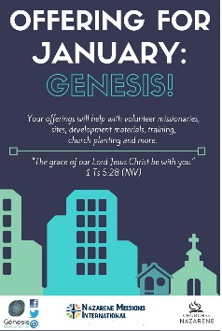

The Genesis Initiative is a project that seeks to develop the Church of the Nazarene in urban cities and islands where there are no churches in the Mesoamerica Region, through church planting, strengthening leaders and sending volunteer missionaries for a period of 2 years.

It seeks to find, train, and send 112 volunteer missionaries to 28 designated sites.

At present, 37 missionaries have served in different cities of the Mesoamerican Region, with little or no Nazarene presence.

In cities or islands, there will be support from local superintendents, pastors and ministries to develop the vision established in each of the sites and thus plant new churches.

Each January, NMI promotes a special offering to help with training and other expenses for those who are being sent to serve in this initiative.



**February**

**Alabaster Offering**



Alabaster funds are used to purchase land, build schools, hospitals / clinics, missionary / national leader homes, mission / district centers, and other buildings needed to make Christlike disciples in the nations.

The buildings constructed with the Alabaster Offerings are more than church buildings; many are also used as child development centers and other places of worship. When we give Alabaster, lives change.

**March**

**Mobilization – The Call**



God is calling children, adolescents and youth to be witnesses wherever they are.

Our challenge is as a church we must guide the new generations of children and youth as they grow up, so that they become adults committed to the Great Commission, developing their spiritual life, teaching them to walk with God and preparing them from an early age to fulfill the ministry according to your calling.



**April**

**WEF – Easter Offering**

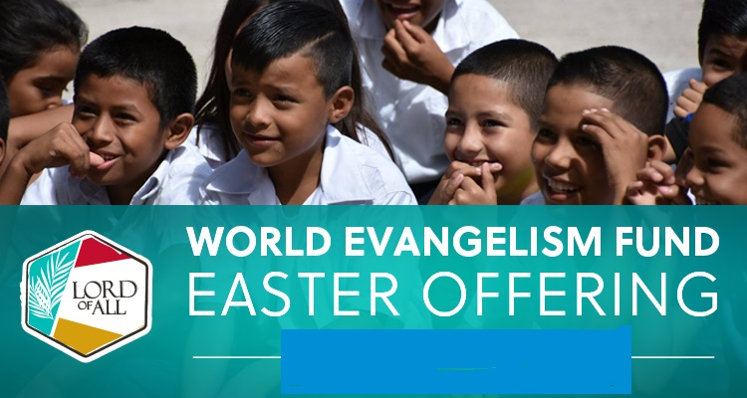

The WEF is the strategic foundation for financing the denomination's mission.

The World Evangelism Fund supports the mission of the Church of the Nazarene by combining the giving of each person and church to fund ministries everywhere. Each church is asked to donate a portion of its annual funds to contribute to the goal of MAKING CHRIST-LIKE DISCIPLES IN ALL NATIONS.

The World Evangelism Fund goes directly to the mission of the Church of the Nazarene.

This is the funding with which the Church of the Nazarene operates and its entire missionary effort, from the operation of the Global Ministry Center to districts and churches around the world.

**May**

**Mobilization - Opportunities to Serve**



The Church of the Nazarene has provided opportunities for those who are called to be a part of God's mission.

There are ministries such as Global Mission, NMI, NYI, and Evangelism, among others, that provide these opportunities for those who are called to experience missions first hand.

The purpose is also to involve people to serve in the different opportunities in missions especially in evangelism to urban missions.

These opportunities help challenge those who are called and to experience missions first-hand. Many of those who participate in these missionary events or trips commit to God to volunteer and as the years go by, God calls them to serve as full-time missionaries at the various scales of missionary ministry.

_______________________________________

_______________________________________

_______________________________________

_______________________________________

_______________________________________

**June**

**Telling the story**

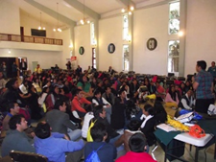

Nazarenes everywhere share the stories of the church's mission. Telling the story instills a passion for the mission. When followers of Christ know what is at stake and hear how others obey God's call to mission, they are challenged to participate as well.

NMI is committed to helping local churches tell the mission story. We provide resources and support for the local church as it informs and educates its members, not only about what other Nazarenes are doing in mission, but how they can participate as well.

Explore the downloads, links and resources on the websites [www.nazarenemissions.org](http://www.nazarenemissions.org) and [www.mesoamericaregion.org](http://www.mesoamericaregion.org) among others and keep telling the story.

The International Missionary Education Guide, Mission Books, videos, missionaries' participation in their tour, missionaries sharing at NMI Conventions, are available resources that tell the story of what God is doing in the Church of the Nazarene around the world.­­­­­­­­

_________________________________________

_________________________________________

_________________________________________

_________________________________________

_________________________________________

**July**

**Youth and Children**

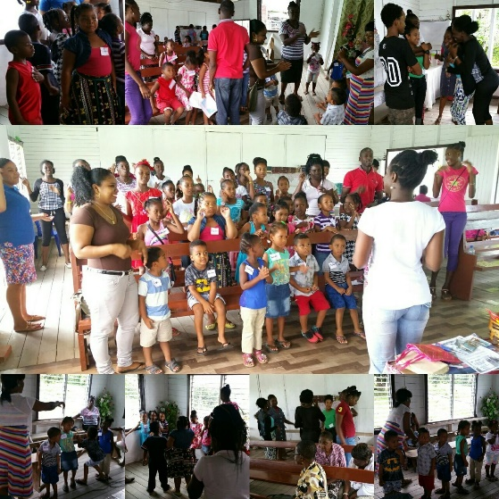

Contrary to what some believe, children and teens have a heart for missions and a passion for serving.

They long to associate with God and participate in God's mission in the world.

If we want younger generations to participate in the life of the church, we must experience cross-cultural transformation in our own lives.

Our minds, hearts, and actions must adapt to minister to young people within the reality in which they live.

**August**

**Mobilization: The Church Sending**

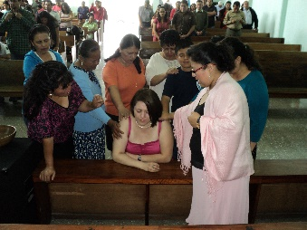

The purpose is that the local Church and the district know and put into practice the commitment they have in sending missionaries.

1. The Church of the Nazarene has 3 core values:

a. We are a Christian people.

b. We are a people of holiness.

c. We are a missional people.

Being a missional people, we say that we are a sent people who, respond to the call of Christ and are empowered by the Holy Spirit, to go into the world, to testify of the Lordship of Christ and participate with God in the edification of the church and the extension of his kingdom. (2 Cor. 6: 1) (School of Leadership – Cross - Cultural Missions - The local church, support of the global mission).

The mission of the church is to reach the world for Christ and in order to fulfill it, it is necessary to develop and send missionaries. *(The Path of Truth 2017)*

*_________________________________________*

*_________________________________________*

*_________________________________________*

*_________________________________________*

*_________________________________________*

**September**

**Alabaster Offering**



An Offering of Love with Fragrant Odor!!

September is one of the two months of the year when, as a denomination, we raise funds through the Alabaster Offering.

The funds are only used for the purpose we all know: construction of churches, chapels, homes for missionaries and national leaders, hospitals, schools, and other church-related buildings around the world.

Statistics for the year 2019 show us that Nazarene believers gave US $ 2.54 million for Alabaster to solve construction projects in 2019.

The Alabaster offering is used in all six world regions.

No Alabaster funds are used to cover administrative costs.

**October**

**LINKS**



It includes caring for missionaries through this program, mission tours, and other opportunities such as Distinguished Service and Memorial Certificates.

The LINKS program was introduced in 1976, expanding the Work Fund to the "adoption" of a missionary family (active or retired) or a missionary.

This still involves praying for them, writing letters, providing cash for personal needs, and remembering missionaries and their children on birthdays, Christmas, and anniversaries.

**November**

**The Persecuted Church**

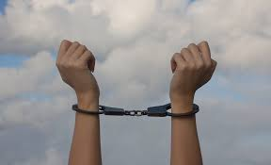

On the second Sunday of every November, NMI unites thousands from around the world in intercession for the International Day of Prayer for the Persecuted Church (IDOP). NMI seeks to draw the attention of Nazarenes to the increasing persecution of Christians.

The main objective of the event is the work of intercessory prayer and citizen action on behalf of persecuted Christians, their oppressors, and for those nations that promote or ignore persecution.

**December**

**Thanks Offering**

**World Evangelism Fund**

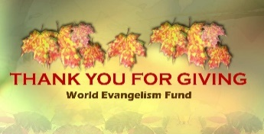

The World Evangelism Fund was created to enable missionaries to work more effectively and

encourage all churches to support missions.

The World Evangelism Fund goes directly toward fulfilling the mission of the Church of the Nazarene, to make Christlike disciples in the nations.

The World Evangelism Fund is the funding that operates the Church of the Nazarene and its entire missionary effort, from the operation of the Global Ministry Center to districts and churches around the world.

**Notes:** _____________________________

___________________________________

___________________________________

___________________________________

___________________________________

___________________________________

___________________________________

___________________________________

___________________________________

___________________________________

___________________________________

___________________________________

___________________________________

___________________________________

___________________________________

___________________________________

___________________________________

___________________________________

___________________________________

___________________________________

___________________________________

___________________________________

Chapter 5

**NMI RESPONSIBILITY IN THE NEW GLOBAL MISSIONS STRATEGY**

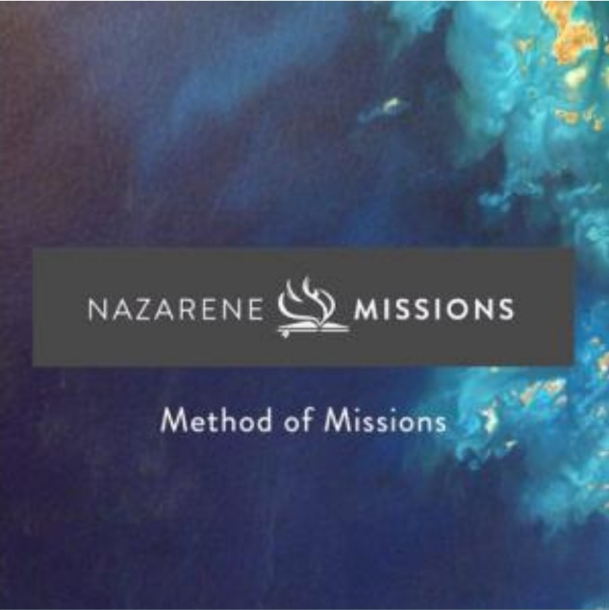

Global Missions is the mission agency of the Church of the Nazarene. The new strategy Introduces a clear process of missionary vocation, sending and return, which includes the local church, NMI, the district, and **Global Missions, repositioning NMI** as the promoter of missions in the local church and Global Missions as the implementation arm of denomination missions.

We affirm the value of the World Evangelism Fund as the strategic foundation for financing the denomination's mission (Handbook, 32.5).

***NMI*** *is critical to funding the mission of the Church of the Nazarene.*

We affirm that it is in the local church that salvation, perfecting, **teaching**, and commissioning take place. (*Manual, Preamble to the Government of the Church*).

Nazarene missionaries partner with local ministers and lay leaders to bring restoration (compassion), share the gospel (evangelism), and build sustainability within the community (education).

Nazarene Missions is woven into the loom of our identity as a people of holiness. Our churches foster the Holy Spirit's call to missions through **mission tour services (deputations)**, **shared stories of God's movement, and special offerings.**

The following table shows us the new Missionary Sending Model:

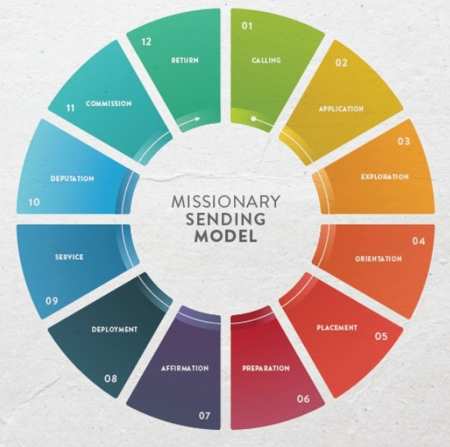

**01 Call**

* The church and district provide opportunities to inspire, foster, and nurture the call to serve in the Nazarene Missions.
* The local MNI president commits in advance; and guides the candidate through the submission process.

**02 Application**

* The candidate engages with church leaders and the local NMI president to establish an interest in missionary service.
* Using the Nazarene Missions guidelines, the candidate meets with the local church board to request a recommendation.
* The candidate receives the official application forms from Nazarene Missions.

**03 Exploration**

* The local church, guided by the NMI president, walk beside the candidate to help him or her discern a call, prepare for service, and develop needed skills.
* Nazarene Missions provides tools and resources to support local church in this process.

**04 Orientation**

* The candidate attends a Nazarene Missions orientation event.
* The candidate, pastor and local and district NMI presidents are notified of the next steps, which may include further assessment and development.

**05 Placement**

* Nazarene Missions notifies local pastors, district and local NMI presidents, and district superintendent of candidate’s placement.
* Missionary assignments are stablish as globally (global) or locally funded (sponsored) prior to placement of candidates.

**06 Preparation**

* Nazarene Missions provides training to prepare the missionary for effective service.
* The local and district NMI presidents encourage the local church and district to support the missionary throughout his or her time missionary service.

**07 Affirmation**

* The local and district NMI presidents prepare a sending service to affirm the missionary in the local church and on the district.
* Each local church and district will receive an affirmation service liturgy, developed by the Board of General Superintendents.
* The local church and district host the affirmation service.

**08 Deployment**

* Nazarene Missions works with field leaders to ensure that the missionary completes field training and successfully begins his or her assignment.
* Field training includes, but is not limited to team bounding, cultural awareness, discipleship training, language acquisition, security and field-specific training.

**09 Service**

* As determined by a missionary assignment, Nazarene Missions provides contractual support: funding, insurance, and member care.
* The local church and local and district NMI presidents keep the relationship strong between the missionary, the district, and the local churches through prayer and connection.

**10 Deputation**

* Globally funded missionaries are equipped with resources that prepare them for deputation services.
* Sponsored missionaries, although not sent on deputation by Nazarene Missions, are connected to their local churches for financial support throughout their assignment.
* Missionaries participate in home assignment, a time intentionally set aside to build, develop, and renew relationships with churches and districts, in order to engage in missions and to encourage World Evangelism giving.
* Nazarene Missions works closely with missionaries to ensure that each presentation reflects excellence.
* Nazarene Missions helps facilitate mission awareness by effectively communicating about missions with districts and local churches.
* The local and district NMI presidents help prepare the sending community to welcome, support and encourage missionaries during their time of home assignment.

**11 Commission**

Nazarene Missions notifies the local sending community, including the local pastors, district and local NMI presidents, and the district, of the commissioning service led by the Board of General Superintendents. Those being commissioned are recognized and sent by the Church of the Nazarene.

**12 Return**

Nazarene Missions helps prepare the church, local and district NMI presidents, and the district to welcome, support, and encourage returning missionaries, including retiring missionaries.

Global missionaries participate in a debriefing and are supported in their transition to their passport countries.

Sponsored missionaries complete a final evaluation and Nazarene Missions follows up with each missionary as needed for further debriefing.

**HOW THE LOCAL AND DISTRICT CAN DISCOVER AND DEVELOP THOSE WHO HAVE CALLED TO THE MISSIONS?**

**The Missionary Call Coordinator**

Purpose: To promote the development of the missionary call in the local churches through the collaborative work of the ministries of NMI and Global Missions through the implementation of the MCC.

Goal: Achieve that 100% of the local churches implement the MCC ministry to continue fulfilling our missionary value as a denomination through virtual trainings directed to the district leaders of NMI.

**What is a mission call coordinator?**

**A new and necessary function.**

Nazarene Missions International recommends that local districts and churches appoint a dedicated leader to serve as the missionary call coordinator (MCC), to be responsible for mentoring children and youth in their missionary call.

The MCC of a local church will need to work with leaders of children and youth ministries to identify those who have a call to missions. You will also need to involve and train other people in this ministry. The MCC cannot perform only everything that involves mentoring the called, but must ensure that all mentoring will be carried out through the participation of other people who have the necessary resources and passion (NMI Manual and Constitution 2009-2013).

The role of this council member is to "find, nurture, and develop children, youth, and young adults who feel God's call to missionary service." NMI recommends that MCC be a member of the NMI Council, Children's Ministry, and the NYI Council, respectively.

**Profile of the coordinator of the missionary call**

**Who can be a MCC?**

MCCs, must be selected in accordance with the NMI Constitution (Article V, Section 1.C.2). Such leaders must possess the gifts, skills, and knowledge necessary to serve effectively in this ministry. We can list the following:

* Love for children and young people (Luke 18:16). It is important that the MCC sympathize with young people and children, that he likes to interact with them, that they like him and he likes them.
* A passion for missions. Many confuse passion with interest. Passion is more than feeling interest, it means living, feeling and loving missions.
* Updated knowledge. Must have knowledge and understanding on topics such as: International Nazarene Missions, Global Missions, denomination structure, region, area, district and local, panorama and reality of the world.
* Communication skills. The MCCs must be very skilled in communicating with all the people to whom they will minister including children and youth. They must create networks of contact with adults (parents, pastors, district leadership, etc.)
* Ability to organize: manage, evaluate, plan, implement, and monitor.
* Creativity necessary to inspire and train other coordinators of the missionary call, to create and promote interactive experiences for youth and children, etc.
* Basic computer skills to communicate with youth and children; report to other leaders, etc.
* Experience as a volunteer missionary if possible.

**MCC Ministry Areas**

**What are the service fields of the MCC?**

The missionary call coordinator is a leader who acts as a facilitator and mentor for those who are called to missions. Before dedicating a person to this role, it must be verified that they meet the characteristics of the MCC profile. This person must have a clear call from the Holy Spirit to carry out this responsibility. Mission facilitators must be mentors. We can see a model of a mentor in the Apostle Paul, who was a prolific teacher and mentor.

Scripture teaches us that true spiritual maturity is acquired through the desire to know Christ and through communion with the people of God. MCCs have a great honor and privilege to serve God by investing in preparing another person for mission service. Jesus Christ is the greatest example as a mentor. Although Jesus is not physically present today, he continues to send mentors through his Holy Spirit.

**District MCC functions**

**What does a district MCC do?**

**The responsibilities of the district MCC are:**

1. Promotes the missionary call through opportunities for children and youth to respond to God's call.
2. Facilitates communication with the mission call coordinators in local churches and the candidate development coordinator in the Global Missions department.
3. Provide training opportunities as needed to local mission call coordinators.

**Local MCC functions**

**What is expected of a local MCC?**

The objectives of the MCC ministry in the local church are as follows:

1. Identify, encourage, and develop children and youth who feel that God is calling them to missions.
2. Connect a child or youth who feels God's call to serve missions with a counselor or mentor.
3. Coordinate follow-up, disseminate information, provide prayer and encouragement to those called to missions.
4. Maintain constant communication with the pastor of your local church, coordinator of the district missionary call and the district coordinator of Global Missions.
5. Collaborate with the district NMI, NYI presidents, and the district superintendent regarding this ministry.

The responsibilities of the MCC with children and young people are:

1. BE WATCHING to discover those who are drawn to missions.
2. AWAKE THEIR INTEREST by involving them in missionary projects.
3. ALLOW THEM TO PARTICIPATE in local missionary activities: missionary studies, missionary projects of Maximum Mission, etc. and serve on the local NMI council.
4. TAKE CARE OF THE SPIRITUAL DEVELOPMENT of those who have a call to missions, encourage them not to lose that call until the time comes to go.
5. If someone is attracted to missions, help by raising funds for MOC (missionary orientation camp) and COMI (children's missionary orientation camp), Genesis project, Missionaries in Voluntary Service, Youth in Mission, among others.
6. INSTRUCT them in everything that refers to missions, that is, disciple them, which means "making Christlike disciples of the nations."

**FINAL NOTE**

The local and district mission call coordinator is in charge of connecting Global Missions with those who have a mission call; providing mentoring and watching over their spiritual development and ministerial training.

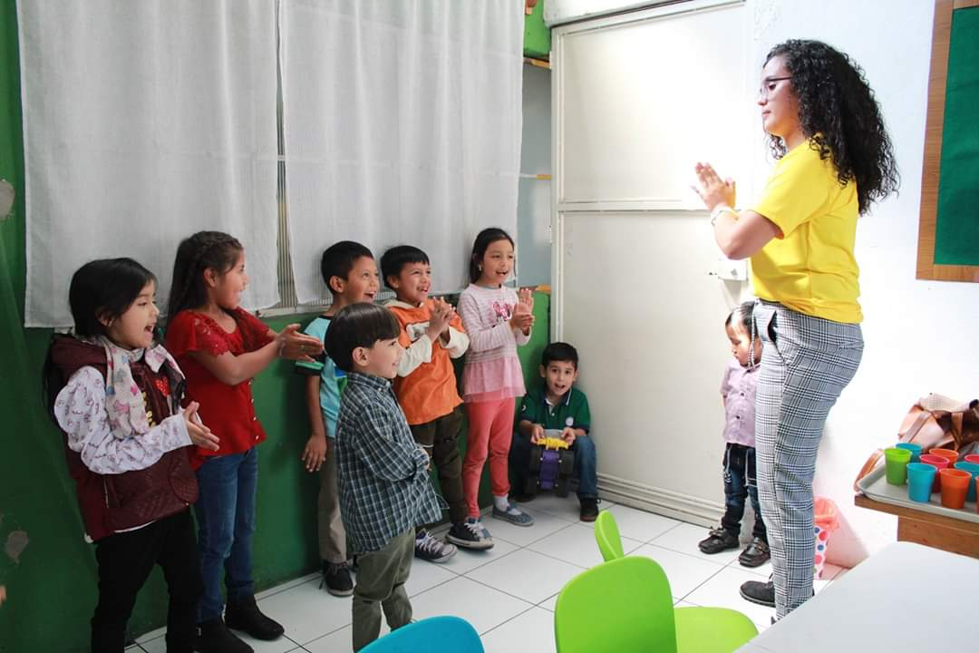

_________________________________________

_________________________________________

_________________________________________

_________________________________________

_________________________________________

_________________________________________

_________________________________________

_________________________________________

_________________________________________

_________________________________________

_________________________________________

_________________________________________

_________________________________________

_________________________________________

_________________________________________

_________________________________________

Chapter 5

**WHAT IS THE WORLD EVANGELISM FUND - WEF?**



It is the financial support system of the missionary work in the Church of the Nazarene to give new life to the unreached.

It allows missionaries to do ministries without the added stress of fundraising for daily life.

**CONTRIBUTIONS TO WORLD EVANGELIZATION**

Nazarene Missions is support through the generous and sacrificial donation of people and churches around the world.

Monetary donations for World Evangelization are the cornerstone of Nazarene Missions. This denominational fund (WEF) is the basis for discovering, delivering, and resourcing our missionary organization around the world.

Each Nazarene church participates in Nazarene Missions through its contributions to World Evangelization offerings. Contributing to World Evangelization is essential for Nazarene Missions initiatives to prosper.

Regarding the generous and sacrificial donation of churches throughout the world, specifically speaking of the Mesoamerican Region, NMI is in charge of promoting effectively in each local church, and for this we are asking the Ministry of Communications for their support, for the preparation of resources (videos especially) to publicize how the WEF is essential in sending and supporting missionaries, both SPONSORED and GLOBAL.

**How is the WEF collected?**

The district establishes a goal and sends it to the local churches so they can send the established amount and it is raised through the offerings of Resurrection, Thanksgiving, Prayer and Fasting, birthdays (some districts are used to doing this) and pledges of faith. The 5.5% goal is measured by the amount of tithes and offerings collected in the previous year at the local church.

**WHAT OFFERINGS DOES THE WEF SUPPORT?**

**EASTER OFFERING**: It is collected on Easter Sunday.

**THANKS OFFERING**. It is usually collected in the month of November in most regions, and in Mesoamerica Region, we established it in the month of December, although some districts continue to do so at their convenience.

**PRAYER AND FASTING OFFERING**. It is a permanent offering that is given regularly during times of prayer and fasting in local churches.

**FAITH PROMISE.** It is a way for us to commit to the Lord to give a certain amount every fifteen days, monthly or as God puts in the hearts of the people to support the Fund for World Evangelism.

By virtue of what we are going through with the Covid-19 pandemic, when we cannot raise offerings in our churches, I suggest that we work with Faith Promise cards and that a way be established in which those responsible can send them.

**WEF ZERO ZEROS**

**What is WEF Zero Zeros?**

A strategy to encourage churches that do not give to the WEF to give and to become **ZERO ZERO WEF CHURCHES.**

Each church that has not contributed to the WEF will be challenged to raise at least one offering that supports the WEF.

Did you know that there **are 586 missionaries,** distributed in the **163 world areas** whose ministries are supported with the WEF?

Did you know that **2/3 of the churches** do not give to the WEF?

In the Mesoamerica Region we are **440,908** Nazarenes in **80 districts** and our goal is that the **3,223** churcheswill be **WEF ZERO ZERO CHURCHES.**

(Church of the Nazarene Global Statistics 2019)

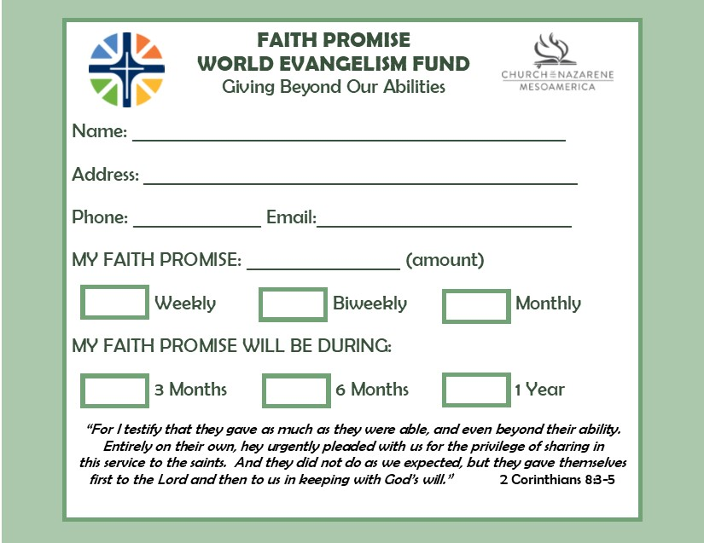

**How are World Evangelism Funds used?**

Most of the people and even pastors say; "So much money" For what? .....

**Here are some quick and important facts:**

* The Church of the Nazarene ministers in 163 world areas. In February, the 2020 General Board approved official entrance into the following world area: Africa Region—Central African Republic.*
* In 2019, there were 586 missionaries originating from 67 world areas. Of these missionaries, 360 served as global deployed and 226 were sponsored deployed. Last year, 86 new missionaries were added. Within the missionary families, there are 312 missionary kids.*
* Churches numbered 30,875 churches (0.53 percent increase) with 2.61 million members (increase of 1.45 percent from last year).*
* 487 districts have been established around the world in 2019 with 29,723 clergy.*
* 5 graduate seminaries/theological colleges, 13 liberal arts colleges/universities, 30 undergraduate seminaries/theological/Bible colleges, 2 nurses training colleges, 1 teacher training college, and 1,411 education centers (extension) had a 2019 combined enrollment of 51,342 students globally.*
* People were treated at community-based clinics and health care centers all over the world with concentrated efforts in India, Papua New Guinea, and Eswatini (formerly known as Swaziland).*
* 196 retired missionaries received pensions.*
* NMI membership was 1,062,516 (an increase of 2.27 percent), and the number of organized local NMIs have risen by 1.78 percent to 18,764.
* JESUS Film Harvest Partners (JFHP) reports that World Evangelism Fund (WEF) helped provide infrastructure for 773 JFHP teams to share God’s love. In 2018–2019, the teams reported 3 million evangelistic contacts. Of these contacts, 685,338 indicated decisions for Christ with 409,585 initial discipleship follow-ups. The teams started 8,770 preaching points in 2019.
* NMI and others partnered with local churches to help raise US $37.6 million through the World Evangelism Fund during the 2019 fiscal year (FY).*
* Churches globally gave US $25.98 million for Approved Mission Specials.
* In 2019, 85 districts gave 5.5 percent of their income and beyond to the World Evangelism Fund. WEF giving beyond 5.5 percent helps open new work, sustains works opened in recent years, and helps send new missionaries that God calls.
* Missionary Health Care provided US $429,257 in medical assistance for Nazarene missionaries.
* Nazarenes gave US $325,628 to World Mission Broadcast (WMB), providing radio, television, and Internet programs to share the gospel globally.
* Nazarenes gave US $3.85 million in deputation offerings for missionaries, up 2.81 percent from FY 2018.
* NMI has more than 205 districts worldwide participating in Links, creating personalized connections between local churches, districts, and missionaries around the world. Each connection is vital in continuing to share about the impact of missions.
* Nazarenes gave US $2.54 million for Alabaster (up 1.55 percent) to fund construction projects in 2019. The Alabaster Offering is used in all six global regions. No Alabaster funds are used for administrative costs.
* International Student Scholarship Fund (NMI 80th Anniversary project) provided 66 scholarships for students outside the USA/Canada to attend Nazarene theological institutions.
* NMI partnered with Nazarene Compassionate Ministries to give more than US $3.98 million for disaster response and compassion projects around the world and to support 11,750 children through Child Development Centers and Pastor’s Kid programs.
* NMI assisted Work & Witness in raising approximately US $1.2 million to deploy 429 teams, an average of 8.25 teams per week. 6,409 people participated in Work & Witness in 2019, donating the equivalent of 342 years of labor.
* Nazarene churches around the world operated 1,379 pre-school, primary, and secondary schools with a total enrollment of 153,328 students.

*\*Supported either directly or indirectly by World Evangelism Fund (WEF).*

*Denominational statistics for 2019*

*NMI 3/2020*

*www.nazarene.org/nmi*

*“Nuevas obras” se refiere a las nuevas áreas mundiales, un área geográfica o nuevas entidades como instituciones. Las áreas pioneras o Distritos Fase 1 se consideran nuevas obras. Cuando un distrito alcanza la Fase 2, ya no se le considera nueva obra.*

_________________________________________

_________________________________________

_________________________________________

_________________________________________

_________________________________________

_________________________________________

_________________________________________

_________________________________________

_________________________________________

_________________________________________

_________________________________________

_________________________________________

_________________________________________

_________________________________________

_________________________________________

_________________________________________

_________________________________________

_________________________________________

_________________________________________

_________________________________________

_______________________________________________

________________________________________

_____________________________________________

Chapter 6

**IDEAS FOR**

**DEVELOPING THE NMI**

**THE PRAYER**



There are many ways to unite your congregation in these times of united prayer, let's look at this idea:

*“The Manual and the NMI Constitution says:“ Prayer is essential and strategic for the work of global evangelization. The Great Commission can be fulfilled as God's people intercede and churches become houses of prayer for all nations. NMI is at the forefront of encouraging Nazarenes to pray for a global mission. "*

*If your church does not have an organized plan that is being used to pray specifically for a global mission, pray and meet with your pastor to create or adopt a plan.*

***How to start a prayer ministry for missions in your church?***

1. *Pray! God wants us to pray; Ask for direction.*
2. *Meet with the pastor and seek his approval.*
3. *Ask God to direct you to the people who will start small prayer groups. (It might surprise you who God chooses).*
4. *Begin first with the people mentioned in # 3, meeting weekly to pray.*
5. *Provide prayer requests from the global Prayer Mobilization Line,* [*https://us16.campaign-archive.com/home/?u=304f5aa03caa8a6cf9a099547&id=dbb14e77f2*](https://us16.campaign-archive.com/home/?u=304f5aa03caa8a6cf9a099547&id=dbb14e77f2) *, or subscribe at this same link, contact the prayer coordinator of the district and personal communication with missionaries and other global entities. (More resources can be found on the NMI website* [*https://nmiideas.org/*](https://nmiideas.org/)
6. *Post global prayer requests through church media (video and print). (Be sensitive to those items in Creative Access Areas or secure areas, and do not include them in print, on websites, or in emails. Such requests should only be mentioned verbally).*
7. *Involve teens and children by leading them to create prayer groups among their peers.*
8. *Send urgent requests by email, text message, or phone message. (Again, keep an eye out for sensitive areas or Creative Access Areas.)*
9. *Encourage each person to follow your example, multiplying the groups according to what God guides you to do.*
10. *Invite everyone to participate in the ministry of prayer for missions.*

*Be the host church in your community for a designated prayer time weekly (go and do so at the community's discretion). Organize prayer walks or prayer walks in designated areas. They include children and adolescents. Be a church that prays!*

*A personal note regarding being a host church in the community: When we pastored in Morgantown, Kentucky, I felt overwhelmed to call the community to pray.*

*Our church was three miles out of town and across a river, it wasn't a prime location for what I wanted to do. My husband, Bill, was good friends with the pastor of First United Methodist Church. I asked the pastor if his church would be willing to host the event, and he kindly opened the doors of his church at 11 a.m. to 1 p.m. every Wednesday. I did all the publicity: newspaper, radio (public service announcement) and letters to all the churches.*

*Although the church was never crowded, there was a flow of people from various churches (including the one and only nun), who came to pray each week. I provided stationery / pens to write down the requests and also provided a printed list of the requests that had been sent to me. The Lord blessed our prayer time; there is no "service", only prayer.*

*Martha Bean*

*US Central Region*

_________________________________________

_________________________________________

_________________________________________

_________________________________________

_________________________________________

________________________________________

_____________________________________________

_______________________________

**WORLD EVANGELISM FUND**

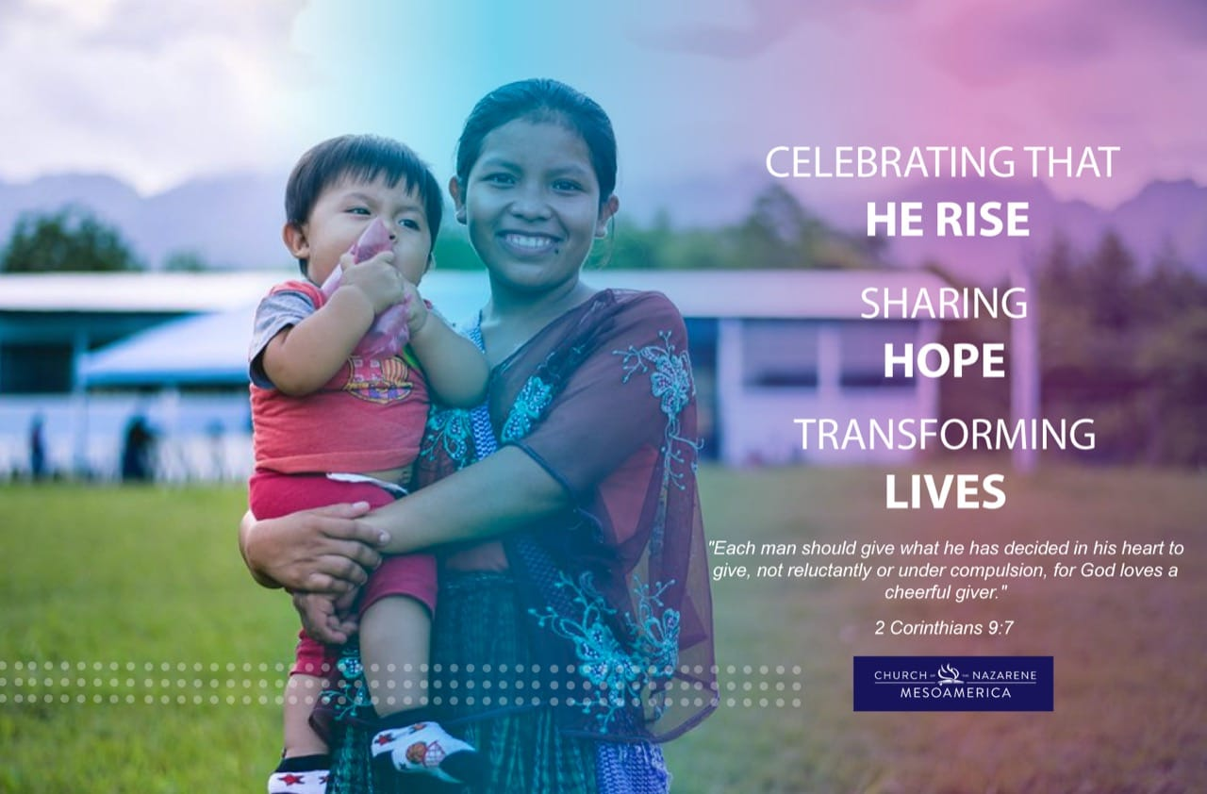

**EASTER OFFERING**

**World Evangelism Fund Calendar leading up to Easter Sunday:**

The season leading up to Easter Sunday is a wonderful time to prepare people's hearts at this time.

Participation in using the World Evangelism Fund Calendar should also serve as a time to prepare your church for the Easter Offering.

People often "give up" (or fast) certain foods or activities in advance of time, recognizing that depriving them helps them focus more on Christ and his sacrifice. The calendar offers suggestions for giving up something for the day. This will be especially good for those who have little experience with fasting.

On Sunday, February 24 (2021), explain to people the purpose of the Easter Offering for the World Evangelism Fund. If possible, show the video of the Offering that has been published on the page <http://www.nazarene.org/generosity>

Tell people that we also have the opportunity to give thanks to God for our salvation and that their gifts will help people all over the world to know the love of God, the sacrifice of Christ, and the comfort of the Holy Spirit.

Distribute or ask people of all ages to prepare 9 "x12" envelopes. Encourage people to put money in their envelopes while following the schedule, and be sure to tell them that they can always give more than the amount listed. (Feel free to adapt it to the currency of your country or area of the world.) Encourage them to write their thoughts and prayers on the outside of the envelope or, for young children, draw what they are praying for.

Tell people they will return their filled envelopes on April 4, Easter Sunday. Let them know that you hope to learn what they experienced during this time and how it helped them celebrate Easter more fully.

Explain to the congregation that on February 24, 2021 we will begin 40 days prior to Easter Sunday and that they prepare their hearts during this time to give with joy to the World Evangelism Fund - WEF.

We start:

**February 24-28 -** Start this calendar by taking these 5 days of Prayer and Fasting. For each time you abstain from eating, donate the equivalent for your Easter Offering, in support of the World Evangelism Fund.

**March 1 -** Read about the temptation of Christ in Matthew 4: 1-11. Donate 10 cents for each year that you have been a Christian. If it's less than a year, donate for each month.

**March 2 -** Ditch the candy today and donate the cost of a candy bar.

**March 3 -** Quit television today and donate at least the equivalent of $ 1.00

**March 4 -** Don't read the newspaper or watch the news today. Take a prayer walk in your city, if this is possible, praying for the people who are there, and then spend some time praying for the lost around the world. Donate 10 cents for each of the times you would normally watch the news.

**March 5 -** No bread today. Donate the cost of a loaf of bread or the bread you did not eat.

**March 6 -** This day do not view your social media. Donate 50 cents for each social media you own.

**March 7 - SUNDAYS ARE FREE! Don't forget to give your ordinary offerings and tithes OJO VER FECHAS AQUI**

**March 8 - Read a Christmas story today to remember the "beginning of the story." Think about the wonder of the Advent season and compare it to this pre-Easter season. Donate 5 cents for every Christmas carol you can think of.**

**March 9 - SUNDAYS ARE FREE! Don't forget to give your ordinary offerings and tithes.**

**March 10 Spend your lunch break (food in other contexts) in prayer. If possible, fast that meal and donate the approximate cost of your lunch.**

**March 11 - No reading for entertainment today. 10 cents for the book or for every book you've read this year.**

**March 12 - Eat quick and cold cereal today and offer 25 cents for each type of cereal in your home.**

**March 13 - Instead of watching videos tonight, spend time in Scripture and donate $ 1 or its equivalent if you own a DVD or have an online video streaming subscription.**

**March 14 - SUNDAYS ARE FREE! Don't forget to give your ordinary offerings and tithes.**

**March 15 - Spend at least an hour reading God's Word and praying today. Donate 25 cents for every Bible you own.**

**March 16 - No red meat today; donate $ 1 or its equivalent to the World Evangelism Fund in your congregation.**

**March 17 - Ditch dessert today and donate the approximate cost of a serving of your favorite type of dessert.**

**March 18 - Read the story of Jesus as a child in the temple. Pray for the children and youth in your church and donate 10 cents for each person under the age of 18 in your extended family (or the immediate family of your close friends).**

**March 19 - Don't have dinner today. Donate $ 5 to increase your congregation's Resurrection Offering.**

**March 20 - Donate some time to help your church prepare for visitors on Easter Sunday. Invite others to join you and donate 50 cents for every hour you volunteer.**

**March 21 - SUNDAYS ARE FREE! Don't forget to give your ordinary offerings and tithes.**

**March 22 - Do not play video games or computer games today. Instead, play a board game with friends and / or family and donate 5 cents to the WEF for each game you have at home.**

**March 23 - If possible, eat only fruits and vegetables today, and give 10 cents for each type of vegetable in your refrigerator or on your shelves.**

**March 24 - Give up the snacks today. Give her 25 cents for each type of chip or treat in her house.**

**March 25 - Read the Sermon on the Mount (Matthew 5: 3-16). Once you're done, write down the Beatitudes themes and donate 10 cents for each one you remember.**

**March 26 - Today there is no cheese or milk. Donate $ 1 or its equivalent to the Easter Offering.**

**March 27 - Donate some time to help your church with a project you have and invite others to join you and donate 50 cents for every hour you volunteer.**

**March 28 - SUNDAYS ARE FREE! Don't forget to give your ordinary offerings and tithes.**

**March 29 - Stop eating chicken today. Donate 50 cents for the number of times you ate chicken in the past week.**

**March 30 - Stop eating dessert or fruit today. Donate 50 cents for dessert or fruit and encourage others to join you.**

**April 1 - In some places people do not eat red meat in the pre-Easter season. If you do not usually abstain from eating them, do so now and donate 1 dollar to the World Evangelism Fund - WEF.**

**April 2 - At this time of year people take a break. Ask each person who took days off to donate the value of what they would spend on ONE vacation day to support the Easter Offering.**

**April 3 - Today, donate the equivalent of what was spent on treats in the break time and continue to support the Easter Offering that will be received tomorrow.**

**April 4 - Easter Sunday. This day bring the Offerings of all that you gathered during this time and thank God for the sacrifice of His Son by shedding his blood on the cross of Calvary to forgive your sins.**

**If this Sunday there is an opportunity to report to the congregation what has been received from the offerings since the beginning of this time and including today's offering, do so. This will motivate the congregation to support the next time it has to raise funds to support the WEF.**

Pueden adaptar esta idea también para la Ofrenda de Acción de Gracias, colocando las fechas que correspondan y que el ultimo día coincida con el día que ustedes levantaran la ofrenda.

**Notas:** ___________________________________

_________________________________________

**IDEAS – “FEM – CERO CEROS”**



Aquí algunas ideas acerca de cómo hacer para promoción a las iglesias para llegar a **ser IGLESIAS FEM CERO CEROS.**

1. Hacer publicaciones en las redes sociales acerca de esta estrategia.
2. Programar talleres para las iglesias locales sobre esta campaña a través de los medios disponibles.
3. Cuando sea posible, aprovechar las visitas a las iglesias que no apoyan el FEM o hacerlo a través de los medios sociales por el momento.
4. Hacer alianzas con otros ministerios claves en esta campaña.
5. Crear un concepto de embajadores Cero Ceros, iniciando desde el liderazgo del distrito.
6. Una vez que una iglesia se convierta en Iglesia FEM Cero Ceros, MNI del distrito nombrará a 2 personas que se convertirán en los “Embajadores Cero Ceros”, quienes grabarán videos para enseñar a otros como lo lograron.

**ideas para las iglesias que dicen**

**no poder dar al FEM**

**Una caja vacía:** Cada domingo se puede colocar una caja vacía en el altar y cuando se recojan los diezmos y ofrendas, quienes lo desean, pueden aportar algo en la caja vacía y eso irá al FEM.

**Énfasis Mensuales**: Utilizarlos para recordar la importancia del FEM.

**Ventas de alimentos**: En donde las ganancias puedan ser enviadas al FEM.

**Ventas de garaje:** Cuyas ganancias se envían al FEM.

**Invitar a un misionero**: Cuando ya sea posible, motivar a la congregación a apoyar el FEM y hablar acerca de la diferencia entre esta y la ofrenda de Gira Misionera.

**Sobres para el FEM:** Aunque no sea el mes indicado, ofrecer sobres cada mes para que recuerden que, aunque sea poco pueden traerlo y esto apoyará el FEM.

**Viajando Alrededor del Mundo**: Cuando sea posible, que el distrito organice un evento donde se muestren las 6 regiones de la Iglesia del Nazareno. Cada uno tendrá un pasaporte y en cada region que visite, deberá pagar un impuesto. Estos fondos irán al FEM y serán contados como una ofrenda de las iglesias locales.

**Tardes de Película:** Proyectar películas y cobrar una pequeña cuota para que haya ganancias para enviar al FEM. Ofrecer también palomitas de maíz, nachos etc. a la venta.

**Incluir a los niños:** Enseñar a los niños sobre el FEM y que ellos también pueden aportar.

**Hacer un concurso** entre ellos y premiar al que mejor decora su alcancía o recipiente donde guarden las ofrendas para apoyar al FEM.

**Huevos de Pascua para el FEM**: Para trabajar con los niños un mes antes del Domingo de Resurrección.

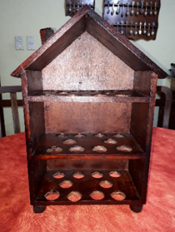 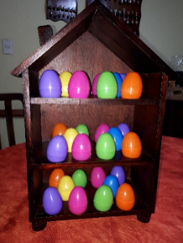 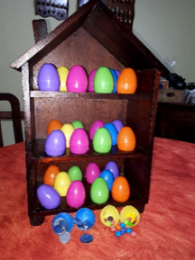

**Notas:** ___________________________________

_________________________________________

_________________________________________

_________________________________________

_________________________________________

_________________________________________

_________________________________________

_________________________________________

_________________________________________

_________________________________________

_________________________________________

_________________________________________

_________________________________________

**OFRENDA DE ALABASTRO**

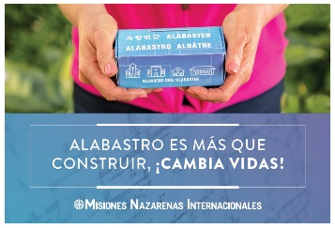

**Alabastro: Moldeando y Dando**

Explique que los fondos de Alabastro ayudan a proporcionar terrenos y edificios en todo el mundo.

Cuente una historia de su distrito acerca de cómo la Ofrenda de Alabastro ha apoyado algún proyecto local a través de un video. Para esto, pida a algún joven que sepa hacerlo a que ayude en esto. Al hacerlo, no solo se hará un buen video con la experiencia que ellos tienen, sino que también lo estarán involucrando en el ministerio.

Ya que se haya dado la información, desafíe a sus congregaciones a participar de un concurso llamado **“Moldeando y Dando a Alabastro”**

¿En qué consiste el concurso?

1. Que cada participante elabore un recipiente de barro, simulando un vaso de Alabastro. El barro se puede comprar en alguna alfarería o en tiendas de manualidades.
2. Pida que durante el mes en que se levanta la ofrenda, sea la de febrero o septiembre, la vayan colocando el recipiente que moldearon
3. Que el momento de la premiación, digan la cada participante que cuente como hizo para lograr el diseño elaborado y como Dios le ayudo a dar su ofrenda aun en tiempo de la crisis que estamos viviendo.
4. Pida a que los concursantes, se inscriban a través del medio social que usted decida.
5. De un plazo en el cual el vaso o recipiente de Alabastro deberá ser presentado.
6. Tenga un grupo de personas que sirvan de jurado calificador para determinar los tres mejores recipientes.
7. Todo esto puede hacerse a través de una reunión por Zoom para que todos puedan apreciar los trabajos realizados.

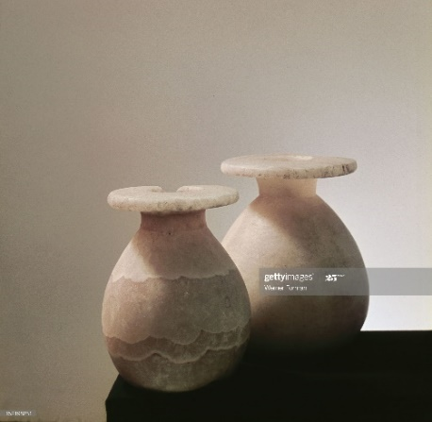

**INVOLUCRANDO JÓVENES Y NIÑOS EN MISIONES**

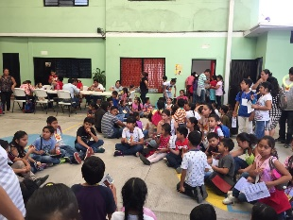

Los jóvenes tienen muchas oportunidades de aprender y ser parte de las misiones en la Iglesia del Nazareno, pero para los niños casi no las tenemos.

**CAMPAMENTO DE ORIENTACION MISIONERA INFANTIL**

**¿Por qué hacer un COMI?**

*“poco se ha hecho para integrar a los jóvenes y menos aún a los niños a este ministerio, la experiencia nos enseña que la proyección que se ha tenido con los niños no ha sido de manera integral… se les ha instruido sobre el mensaje de La Palabra, pero pocas veces se ha llevado a la práctica…”*

Este fue el inicio de un proyecto que con los años se hizo realidad gracias a jóvenes interesadas en llevar a la práctica este sueño.

En el COMI se da oportunidad tanto a jóvenes como niños a ser desarrollados en la misión de Dios: HACER DISCIPULOS SEMEJANTES A CRISTO.

Hoy, se presenta una forma cómo hacerlo virtual, aprovechando que en algunos países de la region muy pronto los niños estarán en vacaciones escolares y es necesario aprovechar este tiempo para discipularlos en la MISION INTEGRAL.



**¿Qué hacer?**

**Duración del COMI:**

1. Se recomienda que sea por lo menos de una semana, tomando una hora cada día, ya que los niños son muy inquietos y no pueden permanecer en línea mucho tiempo.

**Recurso humano:**

1. Los líderes de MNI deberán trabajar en la organización, convocatoria, inscripción y también deberán participar en el campamento en lo que sea necesario.
2. Coordinadores de llamado misionero, coordinadores de Misiones Globales.
3. Jóvenes que hayan participado de un COM o COMI, con conocimiento amplios de uso de plataformas virtuales.
4. Dentro de ellos, deberán tener dos técnicos en el manejo de las redes para estar dirigiendo la plataforma a usar.
5. Personas, especialmente jóvenes, con destrezas y habilidades para ayudar en el proceso previo para preparar todas las dinámicas virtuales que sean necesarias.

**Recurso Virtual:**

1. Deberán contar con una plataforma, Zoom de preferencia, que no sea la que es gratis porque esta solo da 40 minutos y los padres de los niños participantes muchas veces no tienen la habilidad de reconexión y además se interrumpe un tema que está captando la atención de los niños o se pierde el interés en tanto se reconectan.

**Recurso didáctico:**

1. Cada líder deberá contar con el Manual del COMI para preparar con anticipación los materiales y diapositivas de la presentación, así como familiarizarse bien con el tema que le corresponde.
2. Deberá tomarse en cuenta desde la organización el material de seguimiento a utilizar para que los niños puedan continuar siendo mentoreados, ya sea por sus padres o por el liderazgo de su congregación encargado del ministerio de MNI o del ministerio infantil.

**Reuniones:**

1. Cuando ya se tenga el equipo que apoyara el COMI, reúnanse cuantas veces sea necesario para planear cada tarea necesaria y harán pruebas previas con una semana de anticipación para evitar contratiempos durante el evento.
2. Se recomienda también que antes de cada segmento diario, se conecten con anticipación los lideres quienes estarán dirigiendo el COMI, 45 o 30 minutos como mínimo, para hacer pruebas de sonido, proyección de diapositivas, etc. de cada uno de los que estarán guiando las diferentes temas y dinámicas.
3. Al finalizar el campamento virtual, reunirse nuevamente con el equipo de líderes que participaron para darle seguimiento a los niños participantes.

**ESLABONES**



Ha recibido una asignación para ESLABONES en su distrito o iglesia local, ¿qué hacer?

Generalmente, junto con la asignación de la unidad misionera, se envía un documento con las instrucciones a seguir para hacer la conexión entre ellos y el distrito asignado.

Sin embargo, en este tiempo cuando las giras misioneras, que es una oportunidad en donde muchos misioneros hacen la conexión con su distrito ESLABONES, están suspendidas, presentamos algunas ideas como conectarse con su misionero o familia misionera.

1. Si va a tener una Convención de MNI virtual o presencial, con mucha anticipación haga una invitación a su misionero eslabonado para que sea el orador.
2. Si va a hacer en una reunión de entrenamiento con sus líderes, aproveche al misionero a compartir un tema, especialmente a hablar acerca de cómo el FEM apoya el ministerio asignado.
3. Algunos distritos, en este tiempo de pandemia, cuando los misioneros no pueden estar de manera presencial en sus distritos, han organizado vigilias de oración e invitan a su misionero eslabonado a compartir la palabra o a participar en un tiempo oración.
4. Organice una fiesta de aniversario o cumpleaños de su misionero eslabonado por Zoom e invítelo con tiempo.



* Puede también colectar entre sus iglesias locales una ofrenda para enviarla a través de su oficina del área y region con mucha anticipación para que ellos puedan comprar lo que deseen como regalo de cumpleaños y también compren un pastel, torta o como le llamen en su país para partirlo durante la celebración. (Como esta es una ofrenda de cumpleaños tiene que especificarlo cuando lo envíen a la oficina del área).
* Pídales que cuando sea el día de la celebración, tengan el pastel y los regalos empacados y también tengan artículos de celebración como gorros, pitos, etc.
* Pida también a las personas que participaran de esta fiesta por Zoom a que porten sus gorros y artículos de celebración, así como un pastel unipersonal para unirse a la celebración.
* Invite al superintendente de su distrito o a un pastor a que traiga la meditación de la palabra y a un joven que les ayude en un tiempo de juegos o cantos durante la celebración y que no falte un tiempo de oración por sus misioneros eslabonados.

1. Recuerden también a sus iglesias locales, en donde sea posible, levantar en el mes que hacemos énfasis en ESLABONES, una ofrenda para sus misioneros.
2. Cada mes, pida a sus misioneros le envíen peticiones de oración. Prepare tarjetas electrónicas de oración y envíelas a las iglesias para que estén orando por ellos. Incluya también a los niños para que oren por los hijos de los misioneros.

En este tiempo, mientras los misioneros están haciendo el ministerio desde sus casas, las oraciones y la comunicación con ellos son muy importantes y necesarias.

**INICIATIVA GENESIS**

**OFRENDA ESPECIAL**



Recuerden que en el mes de enero de cada año en MNI apoyamos la Iniciativa Génesis con una OFRENDA ESPECIAL. La meta es de **1 dólar o su equivalente en moneda nacional** por cada miembro de su iglesia local.

**Ideas para levantar la ofrenda:**

Mientras estamos en pandemia y muchas congregaciones no pueden reunirse puede hacerlo a través de los medios virtuales:

1. Programe con anticipación invitar a un misionero para cada fin de semana de los que están sirviendo o sirvieron en la Iniciativa Génesis para compartir su testimonio. Puede ser un video pregrabado o una transmisión directa por la plataforma de Zoom.
2. Programe tener el video promocional de la Iniciativa Génesis para proyectarlo durante la reunión, si es por Zoom o envíelo junto al video del misionero.
3. A principios de la primera semana, pida a cada persona que ore por el misionero invitado, oren por el sitio Génesis donde este sirve y de 0.25 centavos de dólar o su equivalente o lo que Dios ponga en sus corazones para la Ofrenda Especial de Génesis.
4. A principios de la segunda semana, oren por el misionero invitado para ese día, oren por la ciudad donde este sirve y por una ciudad donde aún no hay Iglesia del Nazareno o hay poca presencia nazarena y donen otros 0.25 de dólar o su equivalente o la cantidad que Dios ponga en su corazón.
5. A principios de la tercera semana, oren por el misionero invitado de ese día, oren por la ciudad donde sirve y por los líderes de Misión Global e Iniciativa Génesis regionales, de área, distrito y locales. Donen otros 0.25 centavos de dólar o su equivalente, o la cantidad que Dios ponga en sus corazones.
6. Para la última semana, oren por el misionero invitado, la ciudad donde sirve y por los que están experimentando un llamado a servir en la Iniciativa Génesis. Recuerden que los niños también experimentan un llamado al servicio y aunque no pueden ir, oren también por ellos para que Dios les use para cuidarles hasta que llegue el tiempo en que ellos pueden servir.

Animen a los miembros de su congregación a donar otros 0.25 centavos y que este día, recuerden también enviar una ofrenda especial para los misioneros, quienes compartieron con ustedes durante este mes.

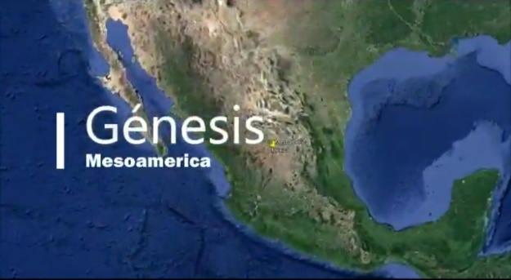

**EN PANDEMIA –**

**¿Y LA CONVENCIÓN?**

Por Alma Hidalgo

Coordinadora MNI Área México Norte



Ha pasado ya tiempo desde que yo escribí en mi blog “Como tener una convención exitosa” dando algunos tips o sugerencias de cómo lograrlo, hoy no solo resulta difícil pensar en volvernos a reunir, sino que hasta las convenciones han sido canceladas o en el mejor de los casos serán virtuales.

Entonces viene a mi mente ese refrán que dice “Nadie sabe lo que tiene, hasta que lo ve perdido”, yo venía haciendo un análisis ya hace algún tiempo en el que las últimas convenciones más que una celebración eran una carga, una molestia y una preocupación costosa tanto para los presidentes como para los superintendentes de distrito, frases como: Disminuyamos el presupuesto, ahorremos hojas en el material, acortemos el tiempo de convención, entre otras, eso era lo que sucedía hace apenas unos meses.

Hoy todo ha cambiado, todo lo que se deseaba quitar, ¡se ha eliminado! Entonces ¿qué hacer?

¿Se puede tener una convención exitosa aun en medio de una pandemia global? Mi respuesta es ¡Claro que se puede!

Y aquí es donde los verdaderos líderes surgen y demuestran su liderazgo, organizando un equipo con las personas creativas, con los jóvenes que conocen la tecnología, con los líderes que no se rinden ante lo desconocido y están dispuestos a aprender y participar de la nueva normalidad.

¿Te animas a hacer una convención virtual? Si tu respuesta es, sí, entonces lo primero que tienes que hacer es poner tus planes en oración y si tus planes coinciden con los de Dios y tu grupo organizador está dispuesto a apoyarte:

1. Necesitarás una plataforma contratada, Zoom, GotoMeeting, Teams, etc.
2. Un administrador de plataforma también es indispensable que lo tengas, pues es quien tendrá la responsabilidad de que toda la convención no tenga interrupciones de sonido, que se proyecten las presentaciones de la mejor manera, y si es necesario que tengan sonido los videos puedan compartirlo con el audio que corresponde, etc., y que de esa manera la transmisión sea lo más exitosa posible.
3. Programa: Ese dependerá de ti y tu equipo, podrás incluir videos, Power Points, conferencias grupales al mismo tiempo, participaciones individuales, grabación del evento, etc. pero la forma en que lo presentes es lo que hará la diferencia.
4. Tú y tu equipo de creativos lo organizan, pero el administrador de la plataforma deberá tener con anticipación todo el material listo unos 15 días antes y poder planear un ensayo previo con toda la presentación de materiales.
5. Te sugiero pienses en algunas tareas especiales para que los participantes se sientan en una nueva y verdadera convención, talvez todos vistan de algún color en especial, un distintivo elaborado por ellos mismos (si te es difícil hacérselos llegar) fondos virtuales iguales, en fin, ¡se creativo!
6. No olvides incluir a los niños en el programa pues ellos también son parte de MNI.
7. El sub-lema en el año eclesiástico 2020- 2021 será “Impactando al mundo – Trabajando juntos.” ¿Por qué no comienzas a practicarlo? ¡Hazlo hoy!
8. Llama a tu equipo y comiencen a preparar lo que será una convención que impactará por el mensaje del evangelio que se expondrá gracias a un equipo que está trabajando juntos.

**Nota:** No quieras presentar sin ensayar antes, ese sería un error.

**NOTAS:** _______________________________

______________________________________

______________________________________

_______________________________________

**Sub Lema de MNI 2020 - 2021**

**IMPACTANDO AL MUNDO – TRABAJANDO JUNTOS**

Por Reyna Guzmán Marmolejo

Distrito Occidente de México



**Escenario:** alguna de las aulas del Edificio de la Iglesia.

*Tener Un tablero de Avisos y Anuncios, en donde se encuentre colocado el Poster publicitario con el sub lema de MNI 2020- 2021*

**Participantes:** Pastor, - 3 jóvenes, y 2 niños.

(De los jóvenes y niños, que participen hombres y mujeres).

El Culto ha terminado, y los hermanos y hermanas (adultos, jóvenes y niños) están platicando y saludándose.

**El Pastor se acerca y se dirige a los jóvenes.** ¡Muchachos! ¿Qué les pareció? ¿Qué piensan del sub lema de MNI escogido para este año?

**Joven 1**: Mmm… pues está bien, pero... ¿trabajando juntos? ¿con los adultos? ¿con los niños?

**Joven 2**: Los adultos sólo nos están regañando y los niños son muy revoltosos.

**Pastor sonriente**: Sin embargo, tanto adultos, jóvenes y niños somos necesarios en la iglesia.

**Joven 1:** Pero ellos ya tienen sus actividades y la verdad yo no quiero andar cuidando niños somos ¡"jóvenes en acción"!

**Joven 3:** Recuerden que fuimos niños! ¡Llenos de energía, y la verdad cuando hay alguna actividad son los primeros que están dispuestos!

**Joven 2:** ¡Tienes razón! Además, como dice el pastor, todos debemos estar dispuestos a involucrarnos en la misión que Jesús nos dejó.

**Niño 1:** (Llegan felices corriendo) ¿Alguien dijo niños? ¡aquí estamos pastor! ¿Qué hacemos? ¿a dónde vamos?

**Niño 2:** Sí pastor, ¿a quién vamos a apoyar? ¿a los jóvenes?

(todos ríen, manos arriba) y al unísono exclaman, ¡Que Dios nos vea "Trabajando juntos"! 👏🏼

Salen todos del escenario.

**NOTAS:** __________________________________

_________________________________________

_________________________________________

_________________________________________

_________________________________________

_________________________________________

_________________________________________

_________________________________________

_________________________________________

_________________________________________

_________________________________________

_________________________________________

_________________________________________

_________________________________________

_________________________________________

_________________________________________

_________________________________________

_________________________________________

_________________________________________

_________________________________________

_________________________________________

_________________________________________

_________________________________________

_________________________________________

_________________________________________

_________________________________________

_________________________________________

_________________________________________

_________________________________________

**PÁGINAS WEB y FACEBOOK**

**Página Web Iglesia del Nazareno Global:** <https://nazarene.org/>

**Misión Global Iglesia del Nazareno:**

<https://nazarene.org/es/quienes-somos/organizaci%C3%B3n/ministerios/misi%C3%B3n-global>

**Nazarene Missions (Misiones Nazarenas):** <http://nazarenemissions.org>

**Página Web de MNI Global:**

**Español:** <https://nazarene.org/es/quienes-somos/organizaci%C3%B3n/ministerios/misiones-nazarenas-internacionales>

**Ingles:** <https://nazarene.org/who-we-are/organization/ministries/nazarene-missions-international>

**Ideas de MNI (página en inglés):** <https://nmiideas.org/>

**Viviendo la Misión (Guía de Educación Misionera varios idiomas:**

<https://nazarene.org/who-we-are/organization/ministries/nazarene-missions-international/curriculum>

**Libros Misioneros en varios idiomas:**

<https://nazarene.org/who-we-are/organization/ministries/nazarene-missions-international/nmi-missions-books>

**Region Mesoamerica:** <http://www.mesoamericaregion.org/>

**MNI Region Mesoamerica:** <http://www.mesoamericaregion.org/ministerios/misiones-nazarenas-internacionales/>

**Génesis Region Mesoamerica:** <http://www.mesoamericaregion.org/ministerios/genesis/>

**Misiones Globales Mesoamerica:** <http://www.mesoamericaregion.org/ministerios/misiones-globales/>

**Blog Transforma el Mundo:** <http://transformaelmundo.com>

**Podcast Siervos Inútiles:** <http://www.mesoamericagenesis.org/podcast>

**Recursos Ofrendas que apoya el FEM:** <https://www.nazarene.org/es/generosidad>

**Línea de Movilización de Oración Global:** <http://www.nazarene.org/es/nmi/linea-de-movilizaci%C3%B3n-de-oraci%C3%B3n>

**La Ventana 4/14:** <http://agenciamisionerabaln.weebly.com/ventana-414.html>

**La Ventana 10/40:** <https://www.google.com/search?client=firefox-b-d&q=la+ventana+10%2F40>+

**Cooperación Misionera Iberoamericana - COMIBAN:** <http://www.comiban.org>

**Paginas en Facebook**:

**MNI Region Mesoamerica**

**Global Missions Mesoamerica**

**Mesoamerica Genesis**

**Iglesia del Nazareno Region Mesoamerica**